

Guide to Quiz Creation

**Katherine Grierson**

September 1, 2015

About this Document

This document is to be used by Clients as a guide for how to format questions for quizzes.

Using this format will allow for:

Faster development

Faster QA

Alignment with D2L tools

Easier updating and editing questions

This document provides:

* An outline of how to format questions properly with examples
* A list of considerations for quiz creation
* A table that you can fill out to pass along to your Instructional Designer on how you would like your quizzes set-up in Brightspace
* Step-by-step instructions for importing questions
* A Sample Quiz Template that you can use as a start for creating your quizzes

If you are unsure whether a quiz is the best tool for capturing answers from learners, please check out the [Deciding Between Using Quizzes, Surveys or Self-Assessment Practice Sheet.](https://community.brightspace.com/sharedresources/effectivepractices/deciding_between_using_quizzes_surveys_or_self_assessmentsdocx)

Available Question Options

D2L quizzing tool has numerous options available for question formats. Each format has requirements on how to format the questions, an example of proper formatting and how you can expect the question to appear in Brightspace.

True or False (T/F)

Format for questions:

* 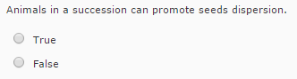Enter your question on a single line

Figure 1: Sample of T/F Question in Brightspace

* Enter the answer on the next line

**Example:**

3. Water consists of hydrogen and oxygen.

True

Multiple Choice (M/C)

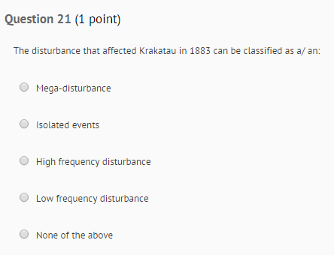Format for questions:

* Enter your question on a single line
* Enter each option on a separate line
* Indicate correct answer with an asterisk (*)
* Please use Multi-Select for any questions where multiple answers apply rather than creating multiple choice with options such as only A and B apply

**Example:**

1. At pH 7, arginine side chains would be…

*virtually all positively charged

50% positively charged

Figure 2: Sample M/C Question in Brightspace

not charged

50% negatively charged

Multi-Select (M-S)

Format for questions:

* 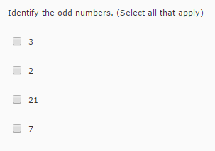Enter your question on a single line include instructions such as (Select all that apply) at the end of the question line

Figure 3 - Multi-Select Question in Brightspace

* Enter each option on a separate line
* Indicate correct answers with an asterisk (*)

**Example:**

2. Which of the following is a planet? (Select all that apply)

The sun

*Earth

Proxima Centauri

*Mars

*Saturn

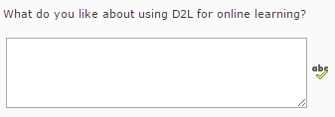Long Answer (LA) – Essay question

Figure 4: Sample Long-Answer Question in Brightspace

Format for questions:

* Type the question with the applicable number
* Leave a blank line after the question

**Example:**

1. What do you like about using D2L for online learning?

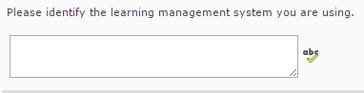Short Answer (SA)

Figure 5: Sample Short-Answer Question in Brightspace

Format for questions:

* Type SA before your question
* All possible correct answers should follow the question text on a new line

**Example:**

SA 1. Please identify the learning management system you are using.

Desire2Learn

BlackBoard

Moodle

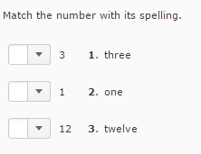Matching (MAT)

Figure 6: Sample Matching Question in Brightspace

Format for questions:

* Type match before your question text followed by a space
* Separate the pairs with a slash ( / ) with a space on each side of the slash

**Example:**

Match 4. Match the number with its spelling.

3 / three

1 / one

12 / twelve

Ordering (ORD)

Format for questions:

* 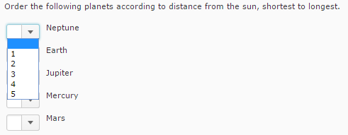Type order before your question text followed by a space

Figure 7: Sample Ordering Question in Brightspace

* List answers in the correct order on separate lines

**Example:**

Order 5. Order the following planets according to distance from the sun, shortest to longest.

Mercury

Earth

Mars

Jupiter

Neptune

Considerations for Question Creation

* Do not put in special characters in question or answer text (such as /, #, $, or %, “”)
* Do not put in any extra text that you do not want included in the questions or options
* The quiz importer tool does not recognize italics or bolding so if you would like to highlight something as important you can use all capital lettering
* Put match, order, SA and LA questions either at the beginning or the end of your quiz so then you can utilize the numbered list functionality in Word more easily
* Attach all pictures that you would like included in the quiz saved as the corresponding number and brief description/title of the question in the quiz
* All pictures that are included in the quiz require either alt text descriptions or the question needs to explain the image fully in order to meet AODA
  + Alt text is very important and needs to explain the picture fully so people with vision difficulties using screen readers can understand the image’s purpose in the quiz
  + Perhaps put the pictures in the following table for easier organization

|  |  |  |
| --- | --- | --- |
| Question Text | Image Name | Alt Text |
| Where in the image below is the equilateral triangle?   1. Right 2. Middle 3. Left | Question 7 | The triangle on the right has two equal sides. The triangle in the middle has no equal sides. The triangle on the right has three equal sides. |

* If you would like students to be shown two different versions of a test you can create a question library and randomize which questions are included (ex. 100 question library but only 50 are shown)
* In situations where you would like learners to add an image or sketch, the best practice would be to include the questions for that section in a word document and turn that section into a dropbox
* Break questions into sections (best practice is 5 questions per page) so answers will be autosaved to reduce the opportunity of losing unsaved answers

Importing Questions into Question Library

After you have worked to create your questions utilizing the Sample Quiz template you can then go ahead and follow the below instructions to import your questions into your course’s Question Library within Brightspace.

***Please note that if you are engaged with D2L Creative Services for creation of courses we will take care of importing your questions on your behalf but for future quizzes/courses you may find the below instructions useful.

1. 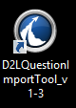Access the [Quiz Question Importer Tool](https://kb.wisc.edu/luwmad/page.php?id=41417) created by University of Wisconsin
2. Download and install the tool
3. Open the D2L Question Library Program
4. 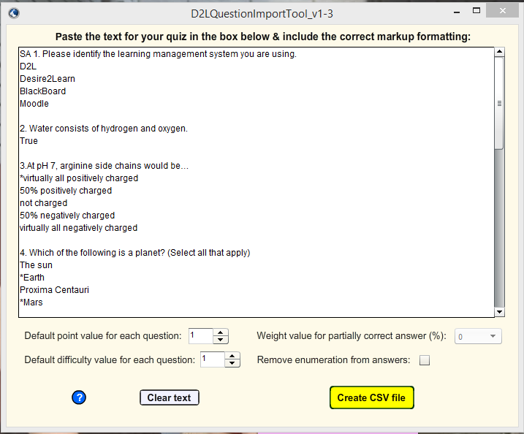Copy and paste your quiz questions into the importer tool
5. Click Create CSV file and save the file
6. Access the applicable course for the quiz with your Brightspace environment
7. 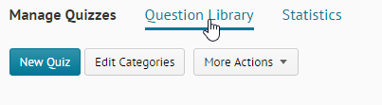Go to Quizzes 🡪 Question Library
8. 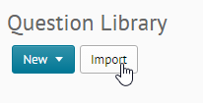Click Import
9. 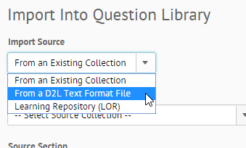In the Import Source dropdown select From a D2L Text Format File
10. Select Choose File and find your saved file from step 5
11. Click Save

Sample Quiz

This quiz template can be copy-and-pasted into a separate word document as the foundation for your quiz creation.

**Reminders**

* + - 1. Put short answer, long answer, match and order questions either at the end or the beginning for easier numbering
      2. Indicate correct answers with **shift-8 (*)** for multi-select and multiple-choice
      3. Indicate **either** true **or** false following the question for true/false questions

LA 1. Write 1-2 sentences on how your learning online has changed since Brightspace.

SA 2. Please identify the learning management system you are using.

D2L

Desire2Learn

BlackBoard

Moodle

1. Water consists of hydrogen and oxygen.

True

1. At pH 7, arginine side chains would be…

*virtually all positively charged

50% positively charged

not charged

50% negatively charged

virtually all negatively charged

1. Which of the following is a planet? (Select all that apply)

The sun

*Earth

Proxima Centauri

*Mars

*Saturn

1. Water consists of hydrogen and oxygen.

True

Match 7. Match the number with its spelling.

3 / three

1 / one

12 / twelve

Order 8. Order the following planets according to distance from the sun, shortest to longest.

Mercury

Earth

Mars

Jupiter

Neptune

About D2L

A global leader in EdTech, D2L is the creator of Brightspace, the world’s first integrated learning platform.   
The company partners with thought-leading organizations to improve learning through data-driven technology that helps deliver a personalized experience to every learner, regardless of geography or ability. D2L’s open and extensible platform is used by more than 1,100 clients and 13 million individual learners in higher education, K–12, healthcare, government, and the enterprise sector—including Fortune 1000 companies.   
The company has operations in the United States, Canada, Europe, Australia, Brazil, and Singapore. [www.brightspace.com](http://www.brightspace.com) | [www.D2L.com](http://www.D2L.com)

Contact Us

Phone: 1.519.772.0325 (Worldwide)

Toll Free: 1.888.772.0325 (North America)

0.808.234.4235 (United Kingdom and Europe)

0.800.452.069 (New Zealand)

1.800.656.210 (Australia)

0.800.891.4507 (Brazil)

Fax: 1.519.772.0324

Email: info@brightspace.com

Twitter: @Brightspace

**Web:** [**www.brightspace.com**](http://www.brightspace.com) | [**www.D2L.com**](http://www.D2L.com)

The D2L family of companies includes D2L Corporation, D2L Ltd., D2L Australia Pty Ltd., D2L Europe Ltd., D2L Asia Pte. Ltd., and D2L Brasil Soluções de Tecnologia para Educação Ltda.

D2L and its logos are trademarks of D2L Corporation, registered in the U.S. and other countries.